NEKTA MANAGEMENT SYSTEM

PROJECT NAME: NEKTA MANAGEMENT SYSTEM
NAME: DANIEL NDUNG’U MURINGE
SCHOOL: STAREHE BOYS CENTER AND SCHOOL
INDEX NO: 20400004183
PAPER: COMPUTER STUDIES
YEAR: 2021
PRESENTED TO: KENYA NATIONAL EXAMINATION COUNCIL

DECLARATION
I declare that I am the sole creator of this wonderful project under the supervision of my teacher Mr. Humphrey Otiende and the blessings of the Almighty God.
I ascertain that this is my work and it is original.

DEDICATION
I hereby dedicate this project work to

ACKNOWLEDGEMENT
I acknowledge the following people who made it possible for me to develop this project work:
- My parent for providing me with financial aid
- The school administration for providing me with the equipment i.e., computers to use in my project work
- My teacher Mr. Humphrey Otiende For equipping me with the necessary educational skills I needed in order to undertake this project work

TABLE OF CONTENTS
Contents
MOVERS TRANSPORT SYSTEM i
DECLARATION ii
DEDICATION iii
ACKNOWLEDGEMENT iv
TABLE OF CONTENTS v
List of figures vii
List of tables ix
Abbreviations x
INTRODUCTION 1
CHAPTER 1: ANALYSIS 2
Problem definition. 2
THE EXISTING SYSTEM. 2
Overview of the existing system. 2
The structure of the system. 3
Advantages of the system. 4
Disadvantages of the system. 4
THE PROPOSED SYSTEM. 5
Scope of the system. 5
Benefits of the new system. 5
Shortcomings of the new system. 6
FEASIBILITY OF THE PROPOSED SYSTEM. 7
Schedule Feasibility. 7
Legal Feasibility. 8
Operational Feasibility. 8
Technical feasibility. 8
Economic Feasibility. 8
System Justification. 10
INVESTIGATION AND FACT FINDING 10
REQUIREMENT SPECIFICATION. 11
Table specification. 11
Form specification 13
Process specification. 16
Hardware and software specification 16
Hardware specification. 16
Software specification. 17
Output specification. 18
CHAPTER 2: SYSTEM DESIGN. 22
Table design. 22
Input screen design 26
Output design 32
Entity relationship diagrams 37
System flowchart design 38
CHAPTER THREE: USER MANUAL 40
A. Installation process and requirement 40
Hardware requirement 40
Software requirement 40
To install the system: 40
Loading process 41
Navigation guide 42
Error Handling 57
CHAPTER FOUR: MISCELLANEOUS 59
Conclusion 59
Recommendation 59
Bibliography 59
Appendices 60
Appendix 1: Problem (Question Paper) 60
FLOWCHART SYMBOLS 63

List of figures
Figure 1: System structure 3
Figure 2:Farm produce entry form 26
Figure 3:Farm inputs entry form 26
Figure 4:Large scale farmers details form 27
Figure 5:Small scale farmers groups form 27
Figure 6:Small scale farmers details form 28
Figure 7:Employee details form 28
Figure 8:Vehicles details form 29
Figure 9:Drivers details form 29
Figure 10:Loaders details form 30
Figure 11:Drivers’ payment form 30
Figure 12: Orders entry form 31
Figure 13: Drivers ‘details report 32
Figure 14:Drivers' payment report 32
Figure 15:drivers' offenses report 32
Figure 16: loaders' details report 32
Figure 17: Loaders' payment report 33
Figure 18: vehicles details report 33
Figure 19:Vehicle expenses report 33
Figure 20:Other expenses reports 33
Figure 21:Other salaries report 34
Figure 22:monthly tax paid 34
Figure 23:Yearly tax 34
Figure 24:Total monthly expenses report 34
Figure 25:Total yearly expenses report 35
Figure 26:monthly transport income report 35
Figure 27:Yearly transport income report 35
Figure 28:Other incomes reports 35
Figure 29:Monthly revenue report 35
Figure 30:Yearly revenue report 36
Figure 31;Monthly company profit report 36
Figure 32:yearly company profit report 36
Figure 33:Company's resources report 36
Figure 34:Company's members report 36
Figure 35:Entity relationship diagram 37
Figure 36:System flowchart 38
Figure 37:system flowchart 39
Figure 53:Splash screen photo 41
Figure 54:Main menu photo 42
Figure 55:Form for driver's details 42
Figure 56:Form for drivers' Offenses 43
Figure 57:LSF-details form 43
Figure 58:LSF-orders form 44
Figure 59:Loaders details form 44
Figure 60:Other employees details form 45
Figure 61:Other expenses form 45
Figure 62:Form for other incomes 46
Figure 63:Form for SSF-groups 46
Figure 64:Form for SSF-details 47
Figure 65:Form for SSFG-orders 47
Figure 66:Form for Vehicle details 48
Figure 67:Report for drivers' details 49
Figure 68:Report for Drivers' offenses 49
Figure 69:Report for large scale farmers 50
Figure 70:Report for loaders information 50
Figure 71;Report for LSF-orders 51
Figure 72:Report for other employee details 51
Figure 73:Report for other expenses 52
Figure 74:Report for other incomes 52
Figure 75:Report for SSF details 53
Figure 76:Report for SSF orders 53
Figure 77:Report showing tax paid 54
Figure 78;Report for total company expenses 54
Figure 79:Total revenue report 55
Figure 80:Vehicle information report 55
Figure 81:Profit of the company report 56
Figure 82:Number of farmers’ error 57
Figure 83:SSF-data entry error 57
Figure 84:Distance travelled error 58
Figure 85:No loaders error 58

List of tables
Table 1: Schedule feasibility table 8
Table 2: economic feasibility table 9
Table 3:Large scale farmers’ table 22
Table 4:small scale farmers groups table 22
Table 5:Small scale farmers details table 23
Table 6:Farm produce details table 23
Table 7:Farm inputs details table 23
Table 8:Employee details table 24
Table 9:Drivers details table 24
Table 10:loaders details table 24
Table 11:Drivers’ payment table 25
Table 12:Orders table 25
Table 13:Details for each vehicle table 61
Table 14:Table for payment of loader and driver 61
Table 15;System flowchart symbols table 63

Abbreviations
- LS-Large scale
- SS-Small scale
- Ksh-Kenyan shilling
- GHZ-Gigahertz
- CD-compact disk
- GB-gigabytes
- DVD-digital versatile disk

INTRODUCTION
Movers is a company that deals with the transportation of various agricultural goods for farmers between farms and retail outlets. The company was started on July 2004 by two businessmen, Mr. Fedart Opollo and Mrs. Linde Wanjala, to help farmers to transport their produce and since then it has grown into a reputable establishment. The company’s headquarters are found in Kitale Town in Transnzoia County. The company works with various large scale and small-scale farmers. The small-scale farmers have organized themselves into small groups called ‘chamas’. The company works with a network of drivers and loaders who are responsible for the transportation. Due to the increasing competition from the upcoming companies and some internal problems that arose due to entropy of the old system, the management of the Movers company has decided to develop a computerize system which they hope will not only improve the operation within the company but will also enable the company to grow. The management hopes that the new system will reduce some of the costs of running activities in the company and increase the company’s profits.

CHAPTER 1: ANALYSIS

Problem definition.
The existing manual system in the Movers company has many shortcomings which are bringing about undue costs to the company and lowering its profits. The growth of the company in the recent years has led to inefficiency in the running of activities in the company. There have been cases of delayed products delivery, some of the produce gets destroyed before reaching its destination among other problems.
The task at hand is to develop a computerized database system for the company that will be able to improve its internal efficiency and hopefully the company’s profits.

THE EXISTING SYSTEM.

Overview of the existing system.
Many processes in the Movers Company are done manually by the employees. All of these tasks carried out are recorded on the record books and stored in the file room of the company. The company works with large scale farmers who are registered individually and small-scale farmers wo have registered themselves as Chamas. The company owns several vehicles including pick-ups, Trailers, Lorries and Refrigerated trucks with which it uses to transport the various farmers’ goods.
In the current system, farmers come to the headquarters to register themselves. Their records are taken by the appropriate employees of the company. In order to make orders for the transport vehicles, farmers who are far write postal letters while those near have to come to the center to make the order. The payments are done on spot. The drivers and loaders are called out at random to drive vehicles and there is no specific routine for servicing and managing the vehicles. The drivers and loaders are paid in a day’s work. All the transactions are done manually.
The process of writing, accessing and updating records is done by employees and the reports are also compiled by the employees. This process is cumbersome and gives inconsistent results. At the end of each year, the company gives a 20% of the total revenue as tax to the government. The company’s profits are also done then.

The structure of the system.
MOVERS TRANSPORT COMPANY
MANAGER
MEMBERSHIPBERSHIP
DEPARTMENTALS HEADS
ACCOUNTANTSS
SECRETARIES
LARGE SCALE FARMERS
SMALL SCALE FARMERS FGARMERS
TRANSPORTBERSHIP
VEHICLESBERSHIP
TYPES OF VEHICLESBERSHIP
DRIVERSBERSHIP
LOADERSBERSHIP
LorryBERSHIP
Pickup
BERSHIP
trailerBERSHIP
Refrigerated truckBERSHIP
Figure 1: System structure

Advantages of the system.
- The company has created many jobs to the locals and even the unskilled personnel are able to work efficiently because there are no complex processes in the company.
- There is a good rapport between employees in the company because they actively interact.
- The company’s processes are cost effective to run because it does not require skilled personnel and the work can be done with little supervision.

Disadvantages of the system.
- There is excess labor in the company and some of it is not well utilized leading to job duplication in the company.
- The records kept in the company i.e.: Farmers, Drivers, Loaders, vehicles and products records are redundant leading to difficulty in c0ompiling expenses reports at the end of each month and year.
- Some records are lost because the filing system is not convenient.
- Some workers have delayed payment and some orders are unattended to leading to dissatisfaction from both parties.
- The management cannot handle their expansive business appropriately because the various activities in the company are hard to track accordingly.
- It is difficult to deal with errand drivers because records of their offenses are not well kept and some drivers pay their way out of the offense.
- The customer care service is not efficient because the farmers complain do not reach the headquarters on time. Most of the complains are not well followed up.
Due to the disadvantages of this manual system, the management has found it necessary to develop a computerized system to replace it.

THE PROPOSED SYSTEM.
The new computerized system is going to be developed in order to address the shortcomings of the manual system. The new system is anticipated to improve the company’s services and hence the company’s profits.
The objectives of the new system are as follows:
- To improve service delivery to farmers
- To improve internal decision making in the organization by making the record keeping process fast and accurate.
- To improve employee and vehicle management.
- To ensure proper record keeping in all departments.
- To improve summary making process in the company
- To ensure that there are quicker and more reliable transaction processes.

Scope of the system.
The expected system is expected to cover the following areas:
Maintaining records of members, vehicles, loaders, drivers, goods transported, orders, offenses and expenses for each vehicle. The system is also expected to generate various reports, Calculate the company’s revenue and overall profits.
Although the computerized system is expected to cover the areas stated above, it is not expected to monitor the employees’ work.

Benefits of the new system.
The proposed system will have the following benefits
- All the records in the company will be kept electronically hence it will be accurate, easy and saves space.
- The new system will support real-time processing hence orders will be well handled and booking of vehicles will be possible.
- Employees will be assigned specific tasks hence there will be no job duplication thus the company will reduce its running costs.
- Orders and payments will be done online thus ensuring safe exchange of money and transactions.
- The data can be easily backed up in the cloud. The data security is well ensured because files can be locked using access level passwords to prevent unauthorized access.
- There will be increased profits in the company because of the efficiency of the new system.

Shortcomings of the new system.
Some of the problems that the new system may face include:
- The initial cost of setting up and running the new system is very high and will reduce the company’s profits.
- Some workers will be retrenched since computers will take over their jobs.
- The company will incur extra costs because of the need to employ skilled personnel.

FEASIBILITY OF THE PROPOSED SYSTEM.
This is the analysis that takes into consideration all the factors involved in developing the new system and establishing whether or not undertaking the project is beneficial to the company.

Schedule Feasibility.
The distribution of the system construction process in the 7 months that I have been allocated is as shown in the table below:
TASK | MONTH | WEEK | ACTIVITY
MILESTONE 1
INITIAL STUDY | July | 2-4 | - Title page set up  - Making preliminary pages  - Introduction
ANALYSIS | August | 1-4 | - Problem definition  - The existing system analysis  - Analysis of the proposed system.
SYSTEM DESIGN | September | 1-4 | - System Flowchart design.  - Making fields ana data types.  - Input design.  - Output design.
MILESTONE 2
SYSTEM CONSTRUCTION | October | 2-4 | - Creating tables and their relationships.  - Making input screens.  - Data Manipulation  - Output screens.
DEMONSTRATION AND DEVELOPING USER MANUAL | November | 1-4 | - Testing the system.  - Navigation and data maintenance  - Input validation.  - Making reports.
MISCELLANEOUS AND DOCUMENTATION | December | 1-3 | - Conclusion.  - Writing a full detailed documentation.
Table 1: Schedule feasibility table

Legal Feasibility.
Developing the system will be under the Nation’s and county’s laws. All the necessary permits are easy to acquire. The system does not violate any stated laws hence it is worth pursuing.

Operational Feasibility.
All the employees of the company were shown the new system and most of them were happy with it. They gave the new system a high rating of 9/10 points.
The farmers who were informed of this new system found it satisfactorily good because it solved most of the problems that they faced owing to the previous manual system.
The management has also agreed to go forward with the new system because they know that with it the company will run much smoother and the profits will increase significantly.

Technical feasibility.
The Equipment needed for developing the new system is readily available in the market. A good system analyst and programmer is also there, me. The company will get 4 more programmers to assist me in developing the new system. The staff group has enough skills to learn how to use the new system.

Economic Feasibility.
This has been done to establish the cost and benefits of running the new system in comparison with the existing manual system. The study finds out whether or not the implementation of the new system is sustainable in the long run. The table below shows the economic feasibility of the two systems:
YEAR 1
AREA | MANUAL SYSTEM | COMPUTERISED SYSTEM
- Staff/Labor | 432000 | 400000
- Stationery | 80000 | 50000
- Electronic accessories | 110000 | 280000
- Electricity cost | 65000 | 130000
- Other management costs | 33000 | 85000
TOTAL COST | 720000 | 945000
YEAR 2
AREA | MANUAL SYSTEM | COMPUTERISED SYSTEM
- Staff/Labor | 420000 | 330000
- Stationery | 65000 | 45000
- Electronic accessories | 90000 | 80000
- Electricity cost | 60000 | 140000
- Other management costs | 25000 | 43000
TOTAL COST | 660000 | 638000
YEAR 3
AREA | MANUAL SYSTEM | COMPUTERISED SYSTEM
- Staff/Labor | 429000 | 200000
- Stationery | 70000 | 38000
- Electronic accessories | 80000 | 65000
- Electricity cost | 70000 | 120000
- Other management costs | 29000 | 22000
TOTAL COST | 678000 | 445000
Table 2: economic feasibility table
Total cost in Three years; -
- Manual system-expensive
- Computerized system-cheaper
The computerized system will be more profitable in the long run.

System Justification.
Developing the new system is possible because all the items needed are available. Pursuing the new system will be costly at first but as it has been seen it will be beneficial in the long run. The new system will contribute positively to the growth of the company as its costs will be less compared to the profits it will bring up in the future. The project is therefore worth pursuing.

INVESTIGATION AND FACT FINDING
The management has seen the benefits that the new system will bring to the company and have decided to go forward with the project. The next task is to find out the user requirements through the collection of facts. In order to do this, I carried out my investigation using the following methods:
- Interviews
I conducted various interviews which involved the farmers, various workers at the company and the management. The interviews mainly involved their opinion on the current system and what they feel about the proposed system.
- Observation
I was able to observe the day to day running of activities in the company. I was able to see the various processes that were undertaken in the company and learn some of the problems that the employees and farmers faced.
- Questionnaires
Due to secrecy and fear of some employees to reveal crucial information about the company, I decided to construct some questionnaires and distribute them randomly to the workers, farmers and management members. This enabled me to get some classified information concerning the company.
- Participation.
For a whole three days, I accompanied a worker, farmer and a manager throughout their days so that I could see their daily activities. This gave me a clear feeling of the way the current system works and how I should improve it in the new computerized system.
- Studying documents.
I visited the company’s file room and saw how the various files were written and stored also got a chance to look at the various reports generated in the company.
Conclusion.
Although the manual system has been working in the company, many of the workers and employees are not happy with it because it is slow and inefficient, in contrary, the embers are happy with the new computerized system because it will make their work easier and the company’s activities will run more smoothly.

REQUIREMENT SPECIFICATION.

Table specification.
- Farm produce table.
- Type
- Amount
- Perishable
- Farm input details table.
- Type
- Quantity
- Price
- Availability
- Large scale farmers details.
- Names, age, gender
- ID number
- Location
- Product
- Telephone No
- Small scale farmers’ groups table.
- Group ID
- No. of farmers
- Name of representative
- ID No. of leader
- Location
- Products.
- Small scale farmers details table.
- Names of farmer, age, gender
- Group ID
- ID number
- Location
- Produce
- Telephone No.
- Employees details table
- Names
- Employee ID
- ID Number
- Telephone Number
- Vehicles details table
- Vehicle type
- Product transported
- Load capacity
- Driver’s name
- Servicing cost
- Fuel Amount used
- Cost per Km
- Drivers Details Table
- Names, age, gender
- Driver’s ID
- Vehicle driven
- ID Number
- Tel Number
- Offenses committed
- Number of trips
- Loaders Details.
- Names, age, gender
- ID Number
- Tel Number
- Vehicle
- Amount Paid.
- Orders table.
- Name
- Group
- Vehicle
- Product
- Location
- Distance
- cost

- Drivers’ payment table
- Name
- ID Number
- Vehicle
- No. of trips
- Offences

Form specification
Farm produce Form
- Type
- Amount
- Perishable

Farm input details Form.
- Type
- Quantity
- Price
- Availability
Large scale farmers details.
- Names, age, gender
- ID number
- Location
- Product
- Telephone No
Small scale farmers’ groups Form.
- Name of group
- No. of farmers
- Name of representative
- ID No. of leader
- Location
- Products.
Small scale farmers details Form.
- Names of farmer, age gender
- ID number
- Location
- Produce
- Telephone No.
Employees details Form
- Names, age, gender
- ID Number
- Telephone Number
Vehicles details Form
- Vehicle type
- Product transported
- Load capacity
- Driver’s name
- Servicing cost
- Fuel Amount used
- Cost per Km
Drivers Details Form
- Names
- Vehicle driven
- ID Number
- Tel Number
- Offenses committed
- Number of trips

Loaders Details Form
- Names
- ID Number
- Tel Number
- Vehicle
- Amount Paid.
Orders Details Form
- Name
- Group
- Vehicle
- Product
- Location
- Distance
- Cost
Drivers’ payment Form.
- Name
- ID Number
- Vehicle
- No. of trips
- Offences

Process specification.
- Compute each of the following:
- Computing the payment for a loader and a driver
- Calculating the penalties surcharged on drivers
- Finding the amount of loading fee per vehicle per trip
- Computing expenses for each vehicle
- Calculate the revenue per vehicle per trip
- Calculating the tax payable by the company
- Computing the total company expenses
- Calculating the total revenue for the company
- Finding the overall profit of the company.

Hardware and software specification

Hardware specification.
- Processor speed: 3.20GHz
- Processor type: Pentium (R) Dual-Core
- RAM size: 16.0 GB
- Hard disk memory space: 500 GB
- Input devices: Pointing devices (PS/2mouse)
Keying in devices (Keyboard)
- Output devices: monitors (High resolution, Touch screen)
Printers (Laser printer)
- Storage devices: flash disks, CDs for backup processes

Software specification.
- Operating system: Graphical User Interface Windows 10
- Application software: Microsoft Suite 2019 with:
            - Microsoft word 2019
            - Microsoft access 2019
            - Microsoft publisher 2019
- System software: Microsoft windows

Output specification.
The following are the output screens:
- Drivers Payment Report.
- First name
- Last Name
- ID Number
- Vehicle
- Amount Per Trip
- Number of trips
- Offenses
- Surcharges
- Total Salary
- Grand Total
- Loaders Payment Report
- First name
- Last Name
- ID Number
- Vehicle
- No. of vehicles loading
- Total Salary
- Grand Total
- Vehicle expenses Report
- Type of vehicle
- Vehicle ID
- Fueling Cost
- Servicing And Repairing Cost
- Insurance Cost
- No Of Times serviced
- Total Maintenance Cost
- Grand Total

- Other Salaries Reports
- First Name
- Last Name
- ID Number
- Amount Paid
- Grand Total
- Other Expenses Report
- Buying New vehicles
- Emergencies
- Office maintenance
- Calling bill
- Electric bill
- Water bill
- Total
- Tax payable report
- Year
- Month
- Revenue
- Tax
- Total expenses report
- Year
- Month
- Drivers’ salary
- Loader’s salary
- Vehicle maintenance
- Other salaries
- Other company expenses
- Tax paid
- Total company expenditure
- Transportation income report
- Vehicle type
- Vehicle ID
- Load capacity
- Cost per Km
- Number of Trips
- Distance Travelled
- Total amount paid
- Other Income generators report
- Selling of old vehicles
- Others
- Total
- Total Revenue generated report
- Year
- Month
- Transport Charges
- Other Incomes
- Grand Total
- Company’s profit report
- Year
- Total Revenue
- Total Expenditure
- Profit
- Company’s Resources report
- Category
- Category ID
- Number
- Farmers Report
- Farmer Category
- Category ID
- Number of Farmers

CHAPTER 2: SYSTEM DESIGN.

Table design.
- Large scale farmers table.
Field Name | Data type
First Name | text
Last name | Text
Age | Text
Gender | text
ID number | Text
Location | Text
Product | text
Telephone number | text
Table 3:Large scale farmers’ table
- Small scale farmers groups table
Field Name | Data type
Name of Group | Text
No. of farmers | Number
Name of leader | text
Tel. of Leader | text
Location | Text
Products | text
Table 4:small scale farmers groups table

- Small scale farmers details table
Field Name | Data type
First Name | Text
Last Name | Text
Age Gender | Text
Id Number | Text
Location | Text
Produce | Text
Tel No. | text
Table 5:Small scale farmers details table
- Farm produce details table

Field Name | Data type
Type | Text
Amount | Number
Perishable | Yes/No
Availability | text
Table 6:Farm produce details table
- Farm input details table
Field Name | Data type
Type | Text
Quantity | Number
Price | Currency
Availability | text
Table 7:Farm inputs details table

- Employees details table
Field Name | Data type
First Name | Text
Last Name | Text
Age | Text
Gender | Text
ID Number | Text
Tel. number | Text
Category | Text
Table 8:Employee details table
- Drivers details Table
Field Name | Data type
First Name | Text
Last Name | Text
Age | Text
Gender | Text
ID Number | Text
Tel. number | Text
Vehicle | Text
Offenses | Number
Table 9:Drivers details table
- Loaders details table
Field Name | Data type
First Name | Text
Last Name | Text
Age | Text
Gender | Text
ID Number | Text
Tel. number | Text
Vehicle loading | Text
Amount paid | Currency
Table 10:loaders details table

- Drivers’ payment table
Field Name | Data type
Name | Text
ID Number | Text
Vehicle | Text
No. of trips | Number
Offenses | Number
Table 11:Drivers’ payment table
- Orders table
Field Name | Data type
Category | Text
First Name | Text
Last Name | Text
Vehicle | Text
Location | Text
Distance | Number
Type of product | Text
Total cost | Currency
Order date | Date/Time
Payment Date | Date/Time
Table 12:Orders table

Input screen design
- The form below allows entry of farm produce details.

Figure 2:Farm produce entry form

- The form below allows entry of Farm inputs details

Figure 3:Farm inputs entry form

- Large scale farmers details form.
Figure 4:Large scale farmers details form
- Small Scale farmers groups form
Figure 5:Small scale farmers groups form

- Small Scale farmers details form
Figure 6:Small scale farmers details form
- Employee details Form
Figure 7:Employee details form

- Vehicles’ Details entry form
Figure 8:Vehicles details form

- Drivers’ details entry Form
Figure 9:Drivers details form
- Loaders Details Form
Figure 10:Loaders details form
- Drivers Payment Form
Figure 11:Drivers’ payment form

- Orders Entry Form.
Figure 12: Orders entry form

Output design
Driver’s Details Report
 | MOVERS TRANSPORT SYSTEM
 | First Name | Last Name | ID Number | Vehicle
1
2
3
4
Figure 13: Drivers ‘details report
Driver’s Payment Report
 | MOVERS TRANSPORT SYSTEM
 | First Name | ID Number | Vehicle | Amount Per Trip | Number of trips | Total Salary
1
2
3
4
 | Grand totals
Figure 14:Drivers' payment report
Driver’s Offenses Report.
 | MOVERS TRANSPORT SYSTEM
 | First Name | ID Number | Offenses | Times Surcharged | Times suspended
1
2
3
4
Figure 15:drivers' offenses report
Loaders details Report
 | MOVERS TRANSPORT SYSTEM
 | First Name | Last Name | ID Number | Vehicle
1
2
3
4
Figure 16: loaders' details report

Loader’s payment report
 | MOVERS TRANSPORT SYSTEM
 | First Name | ID Number | Vehicle | Number of vehicles loading | Total Salary
1
2
3
4
 | Grand totals
Figure 17: Loaders' payment report
Vehicle Details Report
 | MOVERS TRANSPORT SYSTEM
 | Vehicle type | Reg Number | Driver’s Name | Loader’s Name
1
2
3
Figure 18: vehicles details report
Vehicle Expenses Report
MOVERS TRANSPORT SYSTEM
 | Vehicle Type | Reg Number | Fueling cost | Service and repair cost | No of times serviced | Total cost
1
2
3
4
5
Grand Totals
Figure 19:Vehicle expenses report

Other expenses Report
MOVERS TRANSPORT SYSTEM
 | Buying Vehicles | Emergencies | Office maintenance | Calling bills | Electric bill | Water bill
Totals
Grand Totals
Figure 20:Other expenses reports

Other salaries report
MOVERS TRANSPORT SYSTEM
 | First name | Last Name | ID Number | Salary
1
2
3
4
Grand Total
Figure 21:Other salaries report
Monthly tax paid report
Month
Total Revenue | Total expenditure | Tax
Grand Totals
Figure 22:monthly tax paid
Year
 | Month | Tax
1
2
3
4
Grand totals
Total yearly tax report

Figure 23:Yearly tax
Total Monthly expenses report
Month
Drivers’ salary | Loaders’ salary | Vehicle maintenance cost | Other salaries | Other expenses | Tax paid
Grand Totals
Figure 24:Total monthly expenses report
Total yearly expenses report
Year
 | Month | Expenditure
1
2
3
Grand totals
Figure 25:Total yearly expenses report
Monthly transport income report
Month
 | Vehicle type | Vehicle ID | load capacity | Cost Per km | Distance travelled | No of trips
1
2
3
 | Grand totals
Figure 26:monthly transport income report
Yearly transportation income report
Year
Month | Total Income
Grand total
Figure 27:Yearly transport income report

Other income report
Month
Income area | Total
Grand total
Figure 28:Other incomes reports
Monthly Revenue report
Month
Transportation income | Other incomes
Grand Total
Figure 29:Monthly revenue report
Yearly Revenue Report
Year
 | Month | Revenue
1
2
3
Grand total
Figure 30:Yearly revenue report
Monthly company’s profit report
Month
Total Revenue | Total Expenditure | Profit
Grand total
Figure 31;Monthly company profit report
Yearly company’s profit report
Year
 | Month | Total revenue | Total expenditure | Profit
1
2
3
Grand totals
Figure 32:yearly company profit report
Company’s Resources report
Category | Category ID | Number
Figure 33:Company's resources report
Company’s members report
Category | Category ID | Number
Figure 34:Company's members report

Entity relationship diagrams
Figure 35:Entity relationship diagram

System flowchart design
Figure 36:System flowchart
Figure 37:system flowchart

CHAPTER THREE: USER MANUAL

Installation process and requirement

Hardware requirement
- Processor speed: 3.20GHz
- Processor type: Pentium (R) Dual-Core
- RAM size: At least 16.0 GB
- Hard disk memory space: At least 500 GB
- Input devices: Pointing devices (PS/2mouse)
Keying in devices (Keyboard)
- Output devices: monitors (High resolution, Touch screen)
Printers (Laser printer)
- Storage devices: flash disks, CDs

Software requirement
- Application software: Microsoft Suite 2019 with:
            - Microsoft word 2019
            - Microsoft access 2019
            - Microsoft publisher 2019
- System software: Microsoft window7/8/10/11

To install the system:
- Switch on the computer.
- Put the CD or DVD containing the access document into a working CD or DVD drive.
- Locate the Movers Transport System access document on the CD or DVD storage.
- Copy it and paste it on the desktop.

Loading process
- Switch on the computer.
- Once the computer is on, on the desktop, open the access document Movers transport system by double clicking on its icon.
- On opening the system, the splash screen shown below appears:
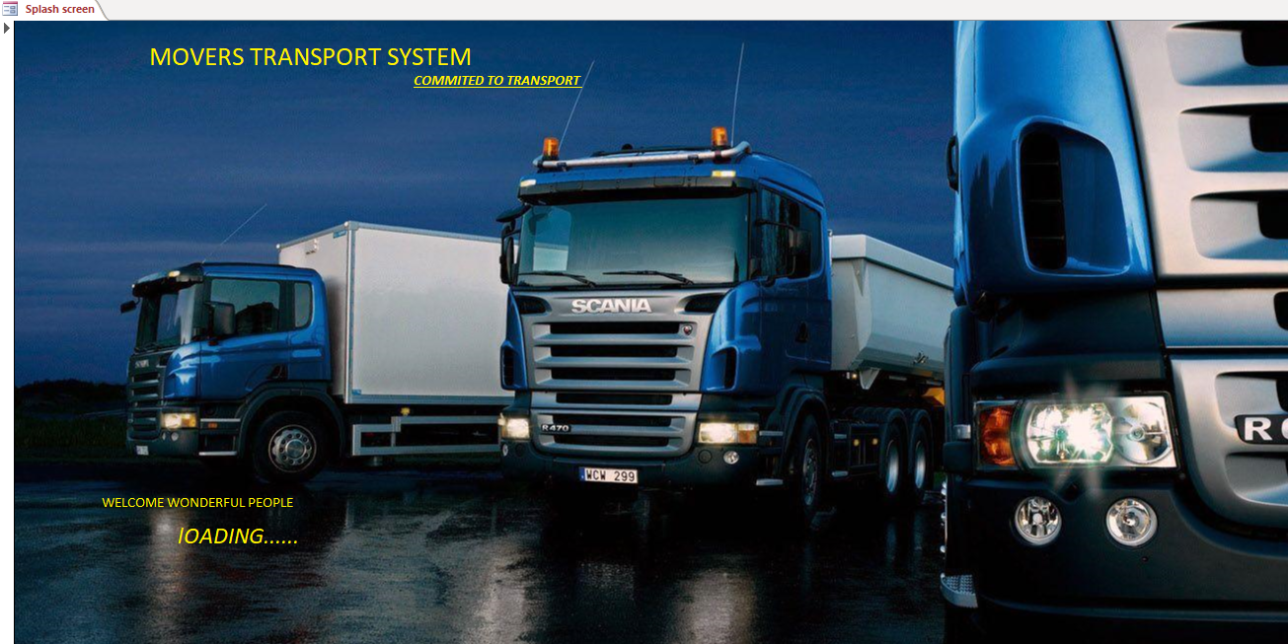
Figure 53:Splash screen photo
- Upon appearing of this screen, you will have to wait for approximately 3 seconds before you see the main menu which appears as follows;
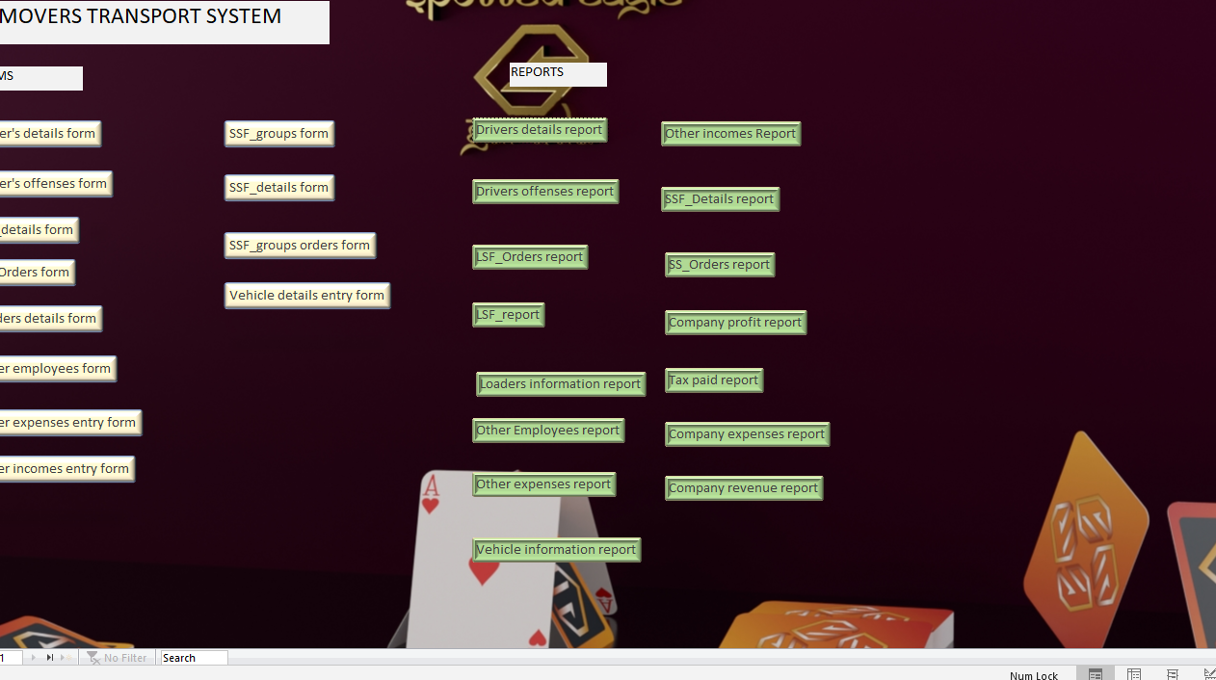
Figure 54:Main menu photo

Navigation guide
- The main menu displays buttons which are used to carry out different functions in the system. Choose the form required by pressing the appropriate buttons.
The following are the forms available in the system:
- Driver’s details form
This form lets you register a new driver into the system.
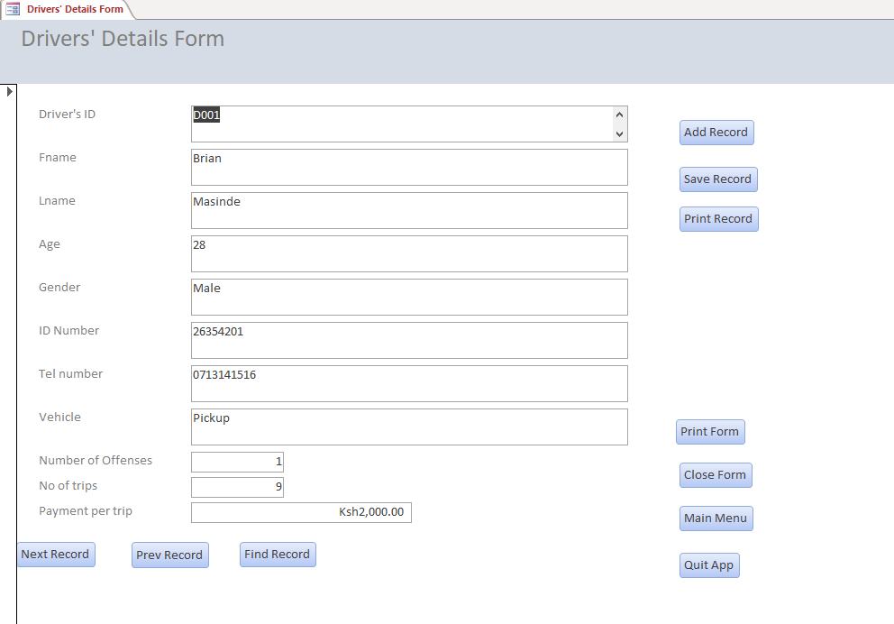
Figure 55:Form for driver's details
- Driver’s offenses form
This form lets you record all the offenses committed by a driver during his working time. The details of the offenses are entered here.
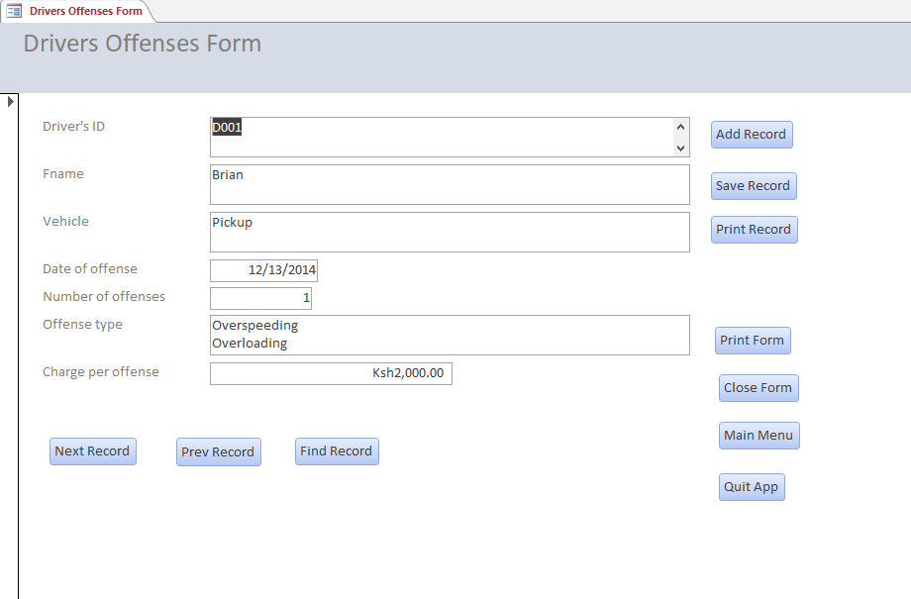
Figure 56:Form for drivers' Offenses

- Large scale farmers details form
Large scale farmers are registered into the system using this form.
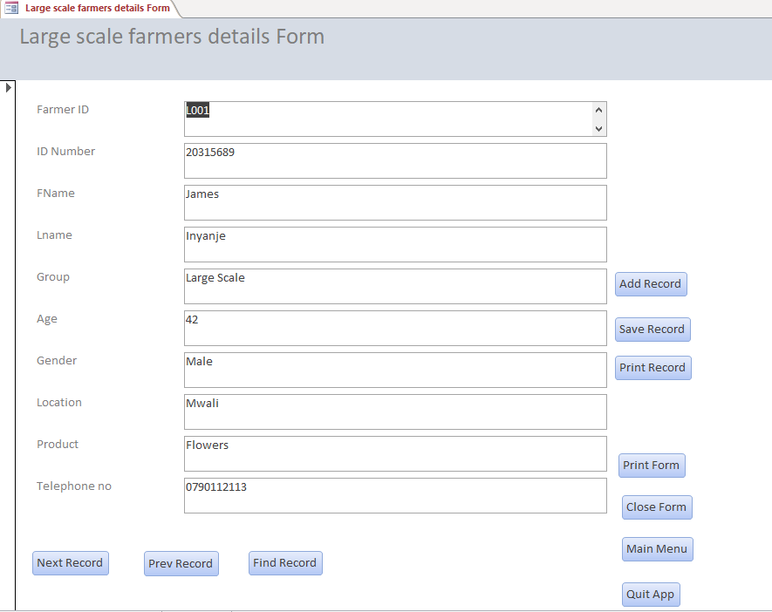
Figure 57:LSF-details form

- Large scale farmers orders form
All the orders placed by large scale farmers are done using this form.
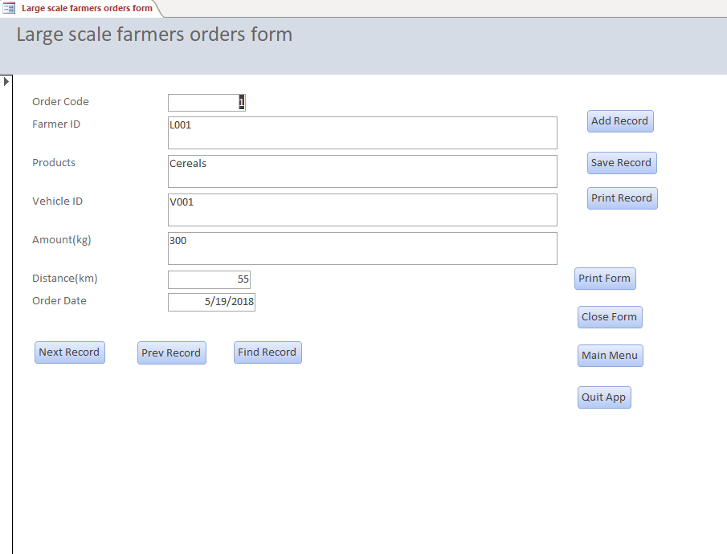
Figure 58:LSF-orders form
- Loaders details form
Details of loaders are recorded into the system using this form.
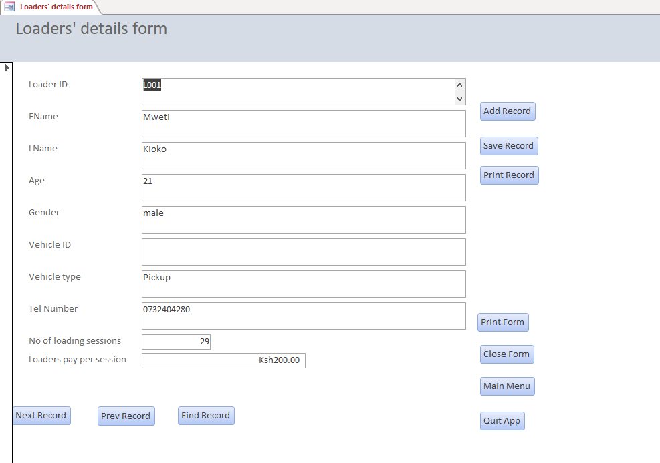
Figure 59:Loaders details form

- Other employees’ details form.
Other employees in the company are registered using this form.
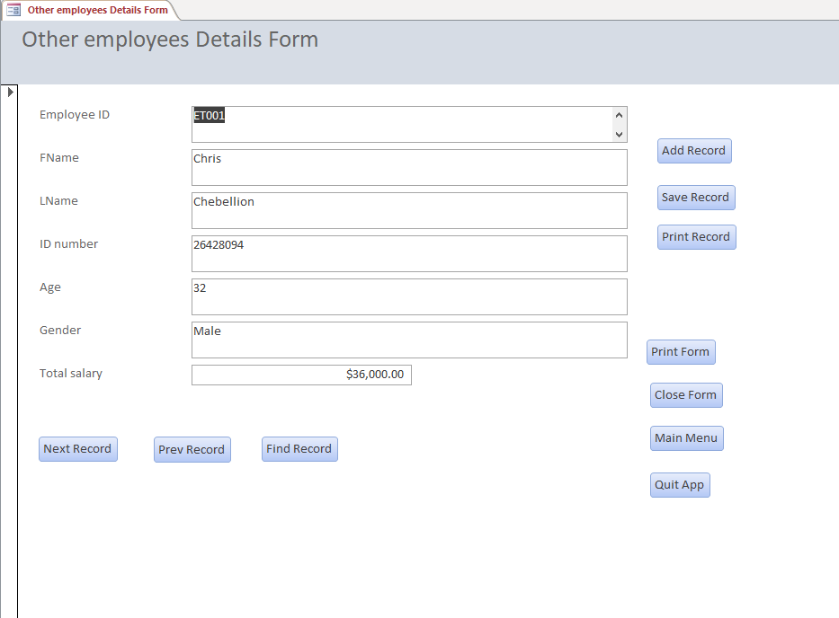
Figure 60:Other employees details form
- Other expenses form
All other expenses that are incurred in the company are recorded using this form.
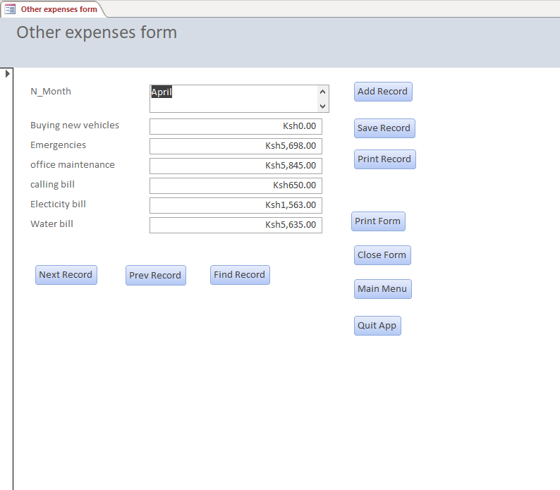
Figure 61:Other expenses form
- Other incomes entry form
All the other incomes generated into the company using other means are recorded using this form.
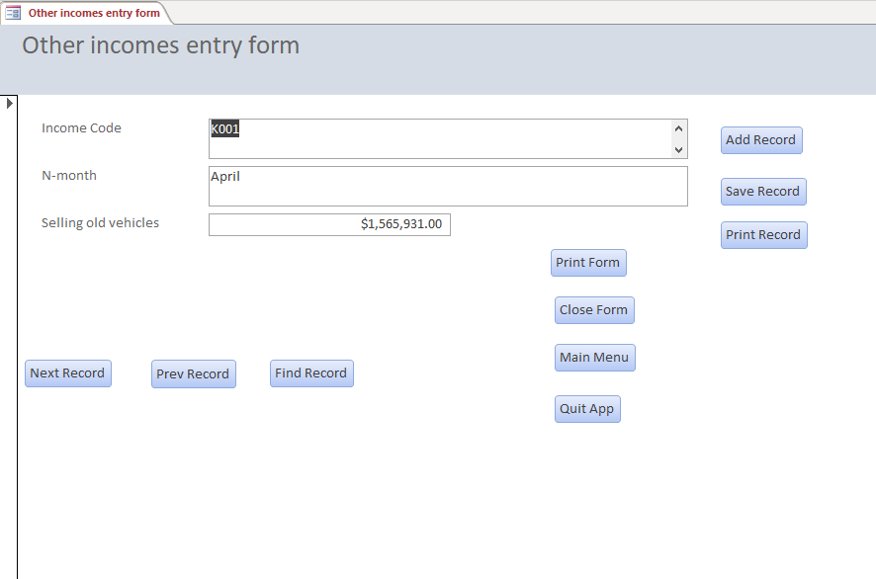
Figure 62:Form for other incomes
- Small scale groups form
All the groups of small-scale farmers are registered using this form.
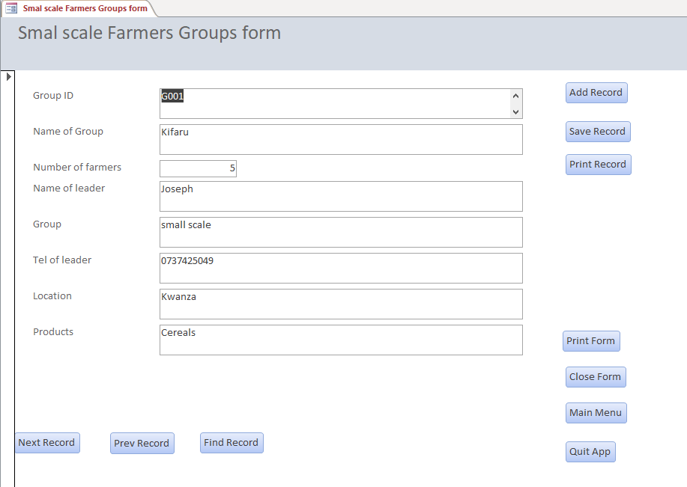
Figure 63:Form for SSF-groups

- Small scale farmers details form
The details of the small-scale farmers who are in groups are recorded using this form.
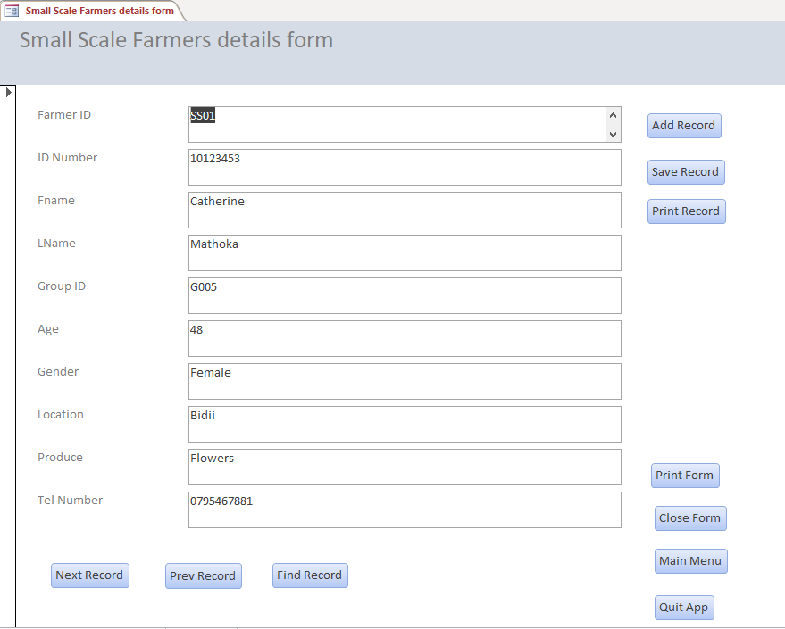
Figure 64:Form for SSF-details
- Small scale group orders form
All the orders placed by the small-scale farmers groups are done using this form.
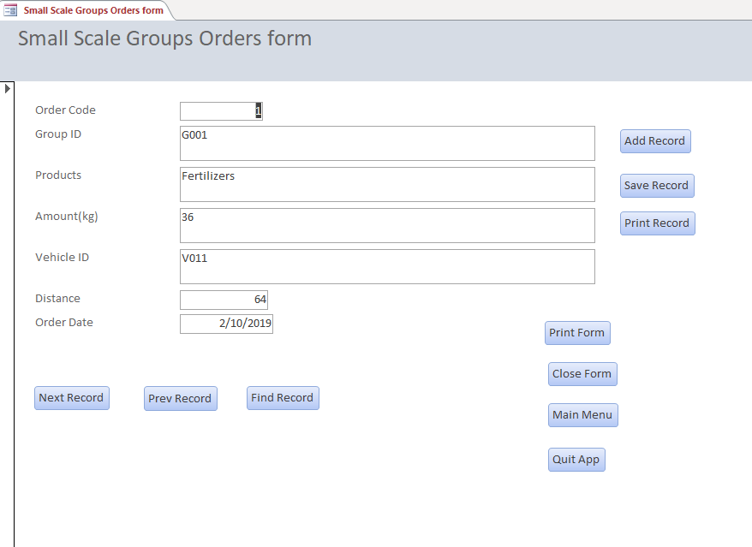
Figure 65:Form for SSFG-orders
- Vehicle details entry form
The various vehicles used by the company are registered using this form.
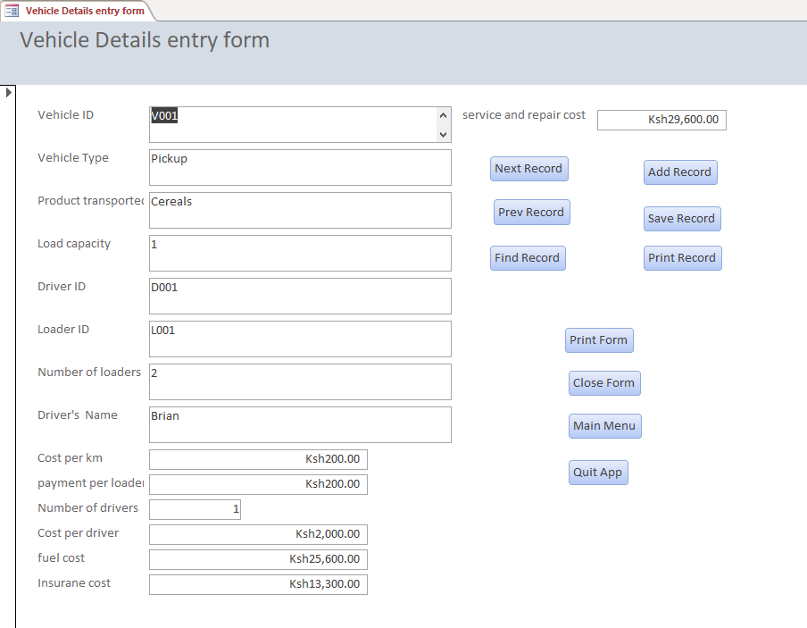
Figure 66:Form for Vehicle details

- The system generates reports as the output.
On the main menu are the various buttons that are used to display the various reports generated by the system. The reports that will be seen are as follows:
- Driver’s details report
The summary for the number of drivers per vehicle and their total salaries will be seen as shown below
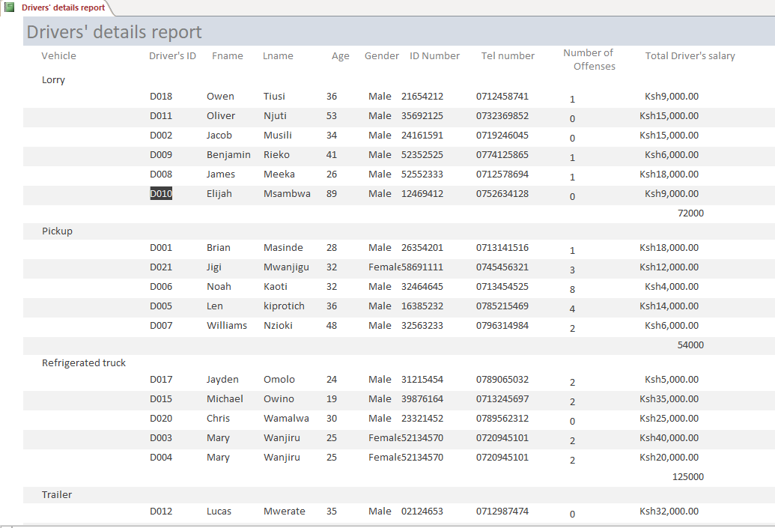
Figure 67:Report for drivers' details
- Driver’s offenses report
The summary for the offenses committed by each driver is seen as shown below
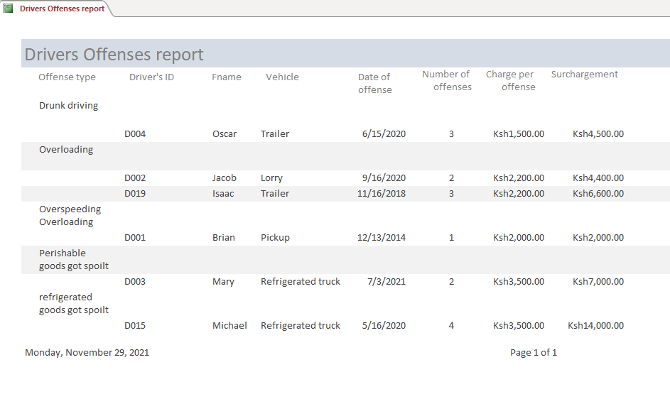
Figure 68:Report for Drivers' offenses
- Large scale farmers report
The summary on large scale farmers will be generated as shown below
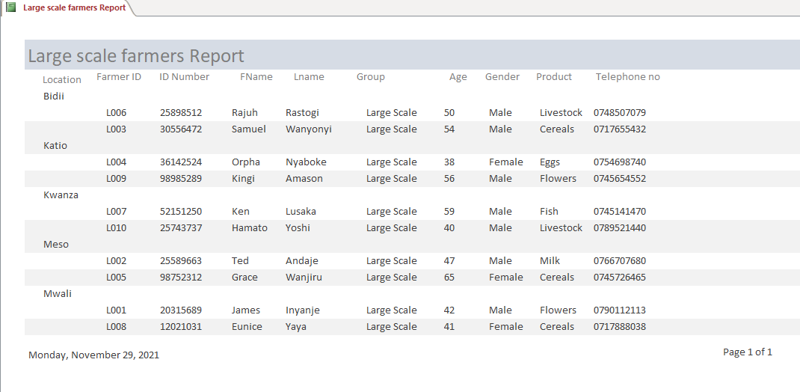
Figure 69:Report for large scale farmers
- Loaders’ information report
The summary on the loader’s information is as shown below
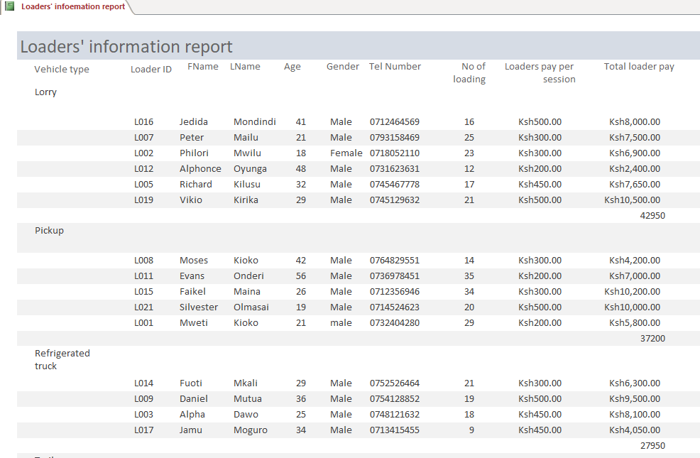
Figure 70:Report for loaders information
- LS-farmers orders report
The summary for the orders done by large scale farmers is as shown below
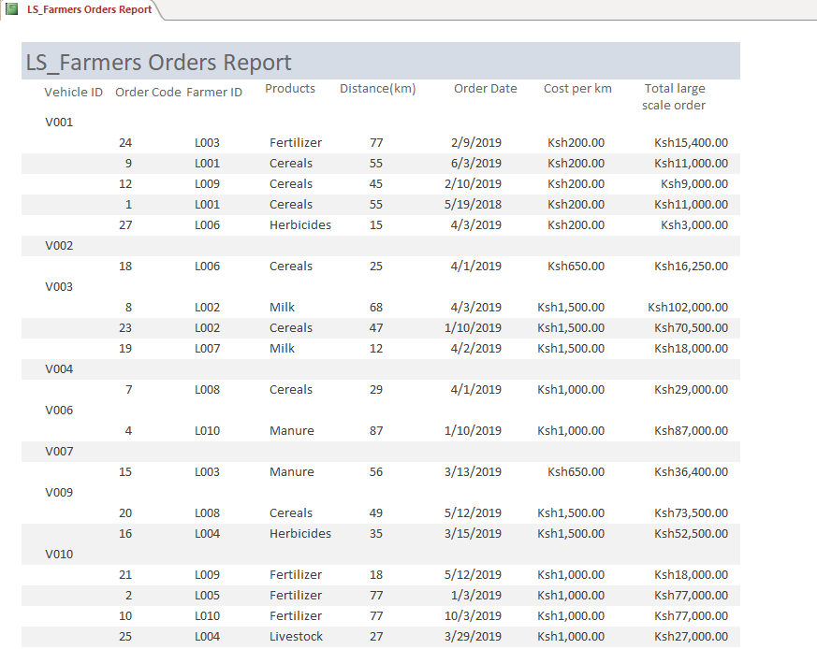
Figure 71;Report for LSF-orders
- Other employees’ details report
The summary for the other employees’ details is as shown below
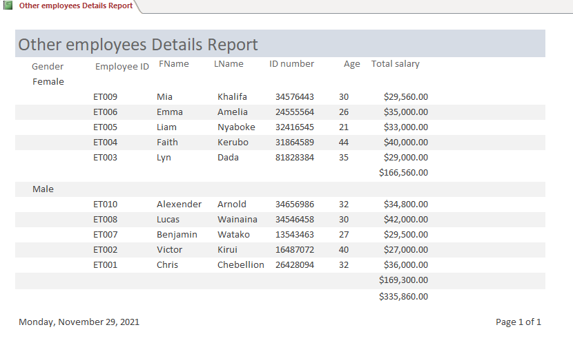
Figure 72:Report for other employee details
- Other expenses report
The summary for other company expenses will be displayed as shown
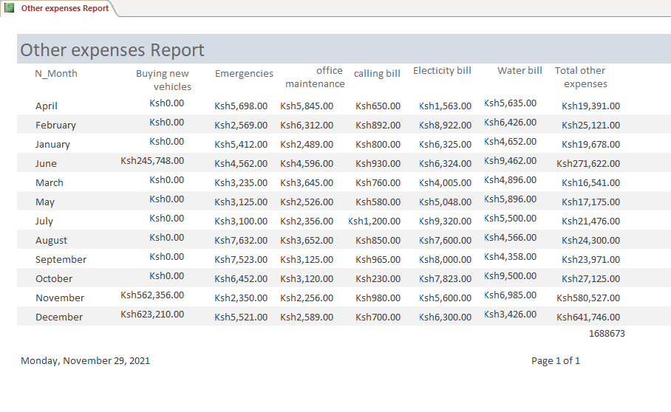
Figure 73:Report for other expenses
- Other incomes report
The summary for the other incomes will be displayed as shown
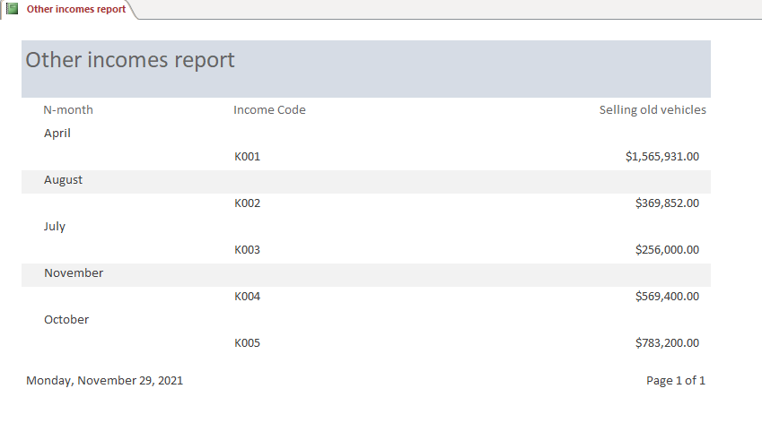
Figure 74:Report for other incomes
- Small scale farmers details report.
The summary of the small-scale farmers will be as shown below;
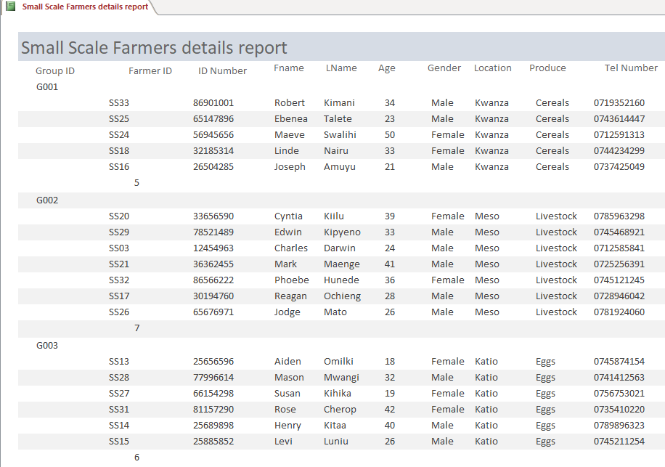
Figure 75:Report for SSF details
- SS-farmers orders report
The summary of the orders done by the small-scale farmers will be displayed as follows
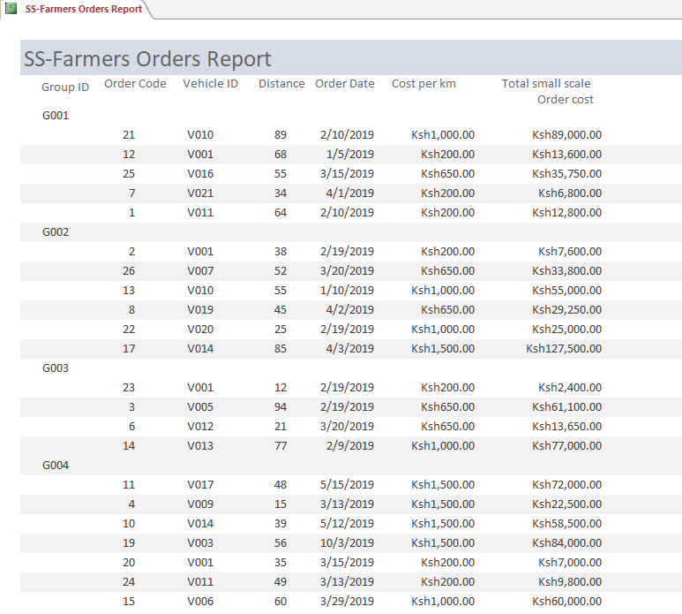
Figure 76:Report for SSF orders
- Tax paid report
The summary of the tax paid by the company to the government will be displayed as shown below
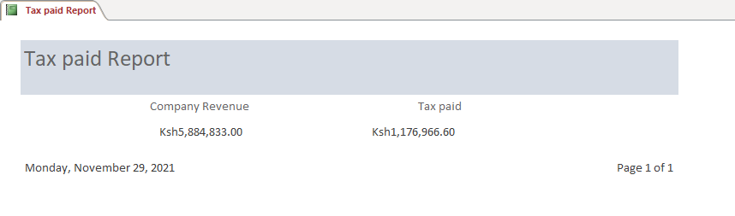
Figure 77:Report showing tax paid
- Total company expenses report
The summary for the total expenses done by the company will be as follows;
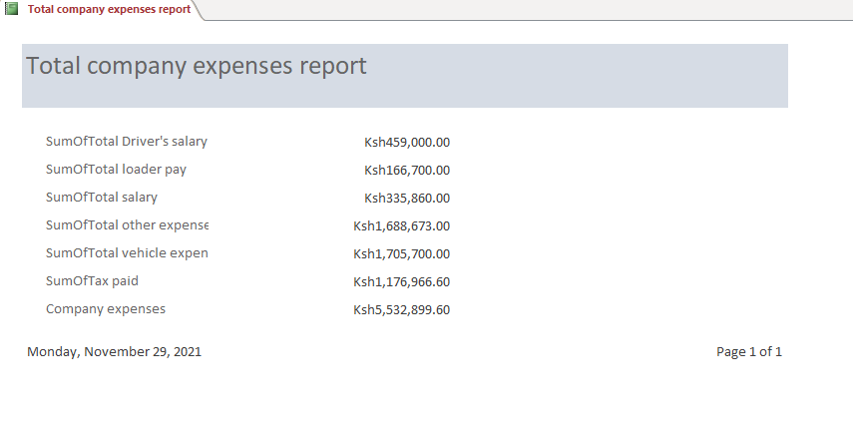
Figure 78;Report for total company expenses

- Total company revenue report
The summary of the total revenue that the company gets is shown as follows;
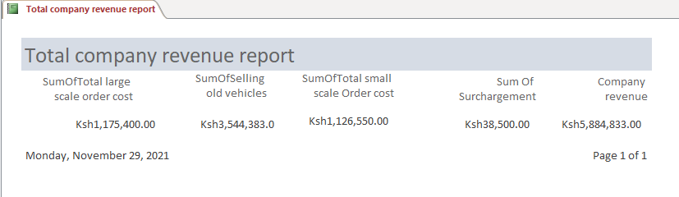
Figure 79:Total revenue report
- Vehicle information report
The summary of the vehicles that the company owns and their various details is as shown below:
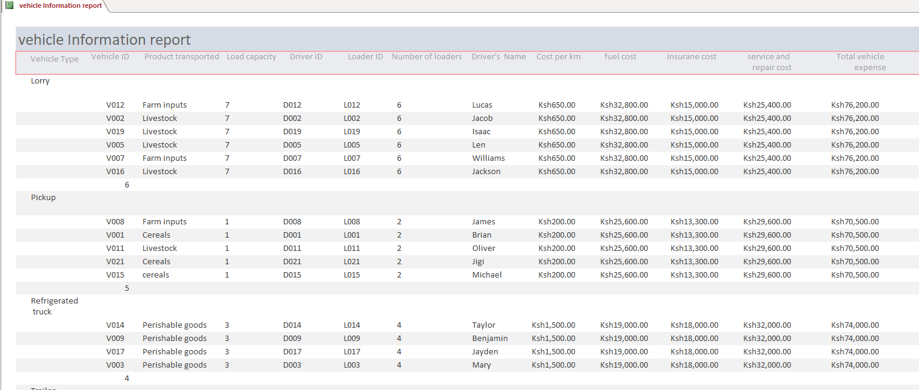
Figure 80:Vehicle information report

- Profit of the company report
The summary of the profit that the company gets will be as shown below
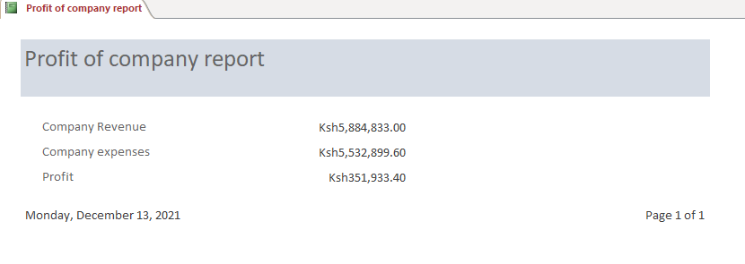
Figure 81:Profit of the company report

Error Handling
Although I have done my best to ensure that this system runs smoothly, there might be minor errors that one may encounter while using this system. The system is designed to display errors in case of data violation of the set validation rules Here I am going to tackle these problems and how best to solve them.
- Number of farmers violation
This error message will be displayed when the number of farmers who are in a new group are less than 5.
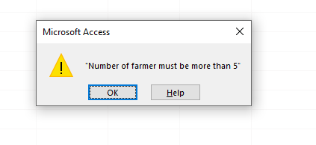
Figure 82:Number of farmers’ error
This error can be corrected by ensuring that each group has at least five farmers.
- Small Scale farmers Entry error
This error will occur when a small scale farmer registeres himself\herself in the large scale farmers details form. The error is as follows;
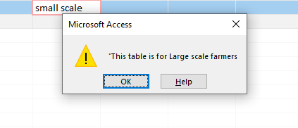
Figure 83:SSF-data entry error

The error can be correctede by using the correct form.

Distance travelled error
- This error occurs when the distance travelled that is entered is 0 or negative. This should be corrected by putting the correct positive number of kilometres.

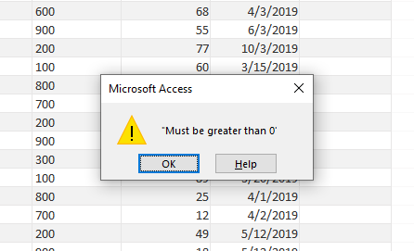
Figure 84:Distance travelled error
No loaders error.
- This error occurs when no loaders have been assigned to a vehicle. It should be corrected by assigning the vehicle the correct number of loaders.

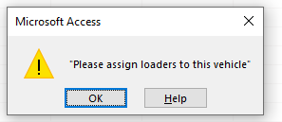
Figure 85:No loaders error

CHAPTER FOUR: MISCELLANEOUS

Conclusion
The journey that I have taken in Making this system for the Movers Transport Company has been very educating. I have developed this system with utmost care and I hope that it is going to bring a lot of efficiency in the company and more profits.

Recommendation
The following are the recommendations for the system:
- In order to ensure that this system runs optimally, the latest operating systems should be used coupled with the hardware specifications provided above.
- In order to prevent data loss from the system through malware attacks or illegal access by spyware, the latest antivirus should be installed on the computers.
- Stringent security measures like burglar proofing and user access passwords should be installed to ensure that the integrity of the data is maintained.
- Any necessary modifications (but with consent of the system developer) can be made to suit the organization’s demands.
- The system should have offsite storage for backup purposes

Bibliography
Longhorn Computer Studies Form Three, by S. Mburu and G. Chemwa; Longhorn Publishers
Longhorn Computer Studies Form Four by S. Mburu and G. Chemwa; Longhorn Publishers
A+ Revision KCSE Computer Studies Question and Answers by H. Otiende, J. Ndede, L. Rono

Appendices

Appendix 1: Problem (Question Paper)
451/3
COMPUTER STUDIES
PAPER 3
(Project)
July 2021 to January 2022
7 months

THE KENYA NATIONAL EXAMINATIONS COUNCIL
Kenya Certificate of Secondary Education
Computer Studies
Paper 3 (Project)
7 months
Instructions to candidates
(a) Candidates are expected to use a Database Management System when developing their projects.
(b) A soft copy of the system and documentation must be stored in a removable storage medium (CD-R/CD-RW/DVD-R/DVD-RW).
(c) Candidate’s name and index number should appear on the cover page of the documentation and on the storage medium.
(d) Each candidate should hand in a hard copy and a soft copy of the project documentation.
(e) Candidates should answer the questions in English.
This paper consists of 3 printed pages. Candidates should check the question paper to ascertain that all the pages are printed as indicated and that no questions are missing. © 2021 The Kenya National Examinations Council Turn over 921116 921116
MOVERS TRANSPORT SYSTEM
Movers is a company that provides transportation for various agricultural goods for farmers between farms and retail outlets. The company transports produce such as cereals, livestock and perishable goods like milk, eggs, fish and flowers. The company also transports farm inputs such as fertilizers, manure, herbicides, pesticides and seeds for planting to the farms.
Large scale farmers register individually as members of the company whereas small scale farmers are required to form groups in order to qualify for membership. A group has a minimum of five farmers and is recognized by a group name, location, nature of farm produce and details of individual farmers. The group can then order for transport as a unit.
The company owns pick-ups, trailers, lorries and refrigerated trucks. The charges for transported goods are based on the means of transport, load capacity and destination as shown in Table 1.
Table 1: Transport charges based on vehicles, load capacity and destination Transport means Load capacity in tones Cost in KSh per km
Table 13:Details for each vehicle table
Pick-up
Lorry
Trailer
Refrigerated truck

The company employs drivers and loaders where each driver is assigned a specific vehicle. Drivers are responsible for the vehicles and ensuring that goods reach their destination in good condition. A driver who commits an offence such as over speeding, overloading, driving while drunk or causes perishable goods to get spoilt due to misconduct is surcharged. A driver is served with a warning letter if surcharged three times in a month. A driver who has been served with a warning letter and commits an offence is suspended from duty for one month. If a driver is suspended twice within a period of six months, his/her services are terminated.
Each vehicle is allocated loaders whenever it is assigned a task. The number of loaders for a vehicle is based on its type as shown in

Table 2: Number of loaders and payments to drivers and loaders based on type of vehicle
Type of vehicle | Number of loaders | Amount paid to loader per vehicle (in KSh) | Amount paid to driver per vehicle (in KSh)
Pick-up | 2 | 200 | 2000
Lorry | 6 | 300 | 3000
Trailer | 10 | 500 | 8000
Refrigerated truck | 4 | 450 | 5000
Table 14:Table for payment of loader and driver
Vehicles are serviced and fueled before each trip and the expenses incurred are recorded.
The company remits 20% of the total revenue as tax to the government.
Develop a well-documented computerized database system for the company that will:
1. Maintain records of membership
2. Maintain records of vehicles
3. Maintain records of loaders and drivers
4. Maintain records of goods transported 5. Maintain records of farmers who are in groups
6. Maintain records of orders for transport
7. Maintain records of offences committed by drivers
8. Maintain records of expenses for each vehicle
9. Compute each of the following:
(i) Payment for a loader and a driver;
(ii) Penalties surcharged on drivers;
(iii) Loading fee per vehicle per trip;
(iv) Revenue per vehicle per trip;
(v) Expenses for each vehicle;
(vi) Tax payable;
(vii) Total company expenses;
(viii) Total revenue for the company;
(ix) Overall company profit.
10. Generate various reports.

FLOWCHART SYMBOLS
SYMBOL | NAME | MEANING
 | Arrow | Show the logical flow of data
 | Document | Opens document/generate report
 | Storage Disk | Updates and access a file in a magnetic disk
 | Parallelogram | Input/output
 | Rectangle | Process
 | Decision Box | Selection of options
Table 15;System flowchart symbols table

